Basketball Dribble Coach

CprE 575 (Computational Perception) Final Project

Matthew Orth

**Abstract**

*Basketball Dribble Coach is a Computer Vision application that helps basketball players improve their dribbling skills. Basketball Dribble Coach does this through real-time camera detection of a basketball player dribbling a basketball. This project will first track the basketball’s position to determine if it has intersected with target locations on the screen, which represent the locations the basketball should be dribbled to by the player. The player’s position also will be tracked to determine the location of the targets. The face of the player will also be tracked to ensure that the player is looking up while they dribble. This functionality will be included in a Qt application. This paper will cover the background of the project and its implementation and evaluation.*

1. **Background**

**Sales Pitch**

Basketball is one of the most popular sports in the world [1]. Basketball is a unique sport in that it enables a person to practice many aspects of the game without the need for other people. The only needed equipment to practice basketball is a basketball hoop and a basketball, which allows a player to practice shooting a basketball. One of the least fun skills to practice in basketball is dribbling. Unlike shooting a basketball in a hoop, practicing dribbling does not provide the same visual satisfaction that making a shot does. Additionally, long-distance shots or difficult shots are frequently included in highlight reels. While dribbling highlights get shown on highlight reels from time to time, they occur far less often, making them less appealing to improve at. However, it can be argued that dribbling is just as important as being able to make shots. Without the ability for a player to dribble, a player will not be able to move very effectively across the basketball court to find open teammates and create shots for themselves.

Basketball Dribble Coach aims to make practicing basketball dribbling more fun. One difficult aspect of practicing dribbling a basketball is the lack of visual feedback on your progress. When a player shoots a basketball into a hoop, they get immediate feedback based on whether the shot goes into the hoop. This type of feedback is not present in dribbling practice unless a player has a coach that gives them real-time feedback as they are dribbling. Basketball Dribble Coach aims to give this feedback to a player without the need for another person giving that feedback to the player. This enables a player to practice dribbling in different settings and without the need to hire a coach. For starters, Basketball Dribble Coach will give the player visual feedback by directly showing a real-time camera feed of them while they are practicing dribbling a basketball. This visual feedback will help the player in many ways. For one, the visual feedback will allow them to see how high, at what location, and at what speed they are dribbling the basketball. In addition to showing the real-time camera of the player, visual indications will be made for the basketball location and the target dribbling locations. This will give the player a goal to strive for. When a player practices dribbling by themselves, it can be difficult to determine whether they are dribbling the ball to the correct location without directly looking down at the basketball. However, looking down while dribbling is not a habit that a player wants to develop as that prevents them from seeing other things on the court. Providing these visual representations within the application through displaying the target dribbling locations will allow the player to create muscle memory of where these locations are such that when they are dribbling outside of practice, they are still maintaining the ball at a low height to enable faster and more controlled dribbling without having to look down at the basketball.

Perhaps one of the biggest areas of improvement, especially for young basketball players, is the ability to keep their eyes up while they are dribbling the basketball. Basketball Dribble Coach will integrate face detection to determine whether the player is keeping their head up while they are dribbling. A basketball player needs to be able to dribble while keeping their head up so that they know where the defenders are and, so they are keeping passing and shooting options available. If a player keeps their head down while dribbling, that usually results in a turnover or a poor resulting play. Since basketball is a sport that is easily practiced without the need for other people, Basketball Dribble Coach will provide this ease of practice dribbling.

**Target Audience**

The target audience for this application can be any range of basketball players looking to improve their dribbling skills. For young or more inexperienced basketball players, this project gives them a fun way to practice dribbling that allows them to visually receive feedback for their dribbling progress. This will be done by allowing the basketball player to see themselves while they are dribbling and keep track of how long it takes them to complete certain drills, so they can improve over time. This project can also be helpful for more experienced basketball players as well as the visual feedback is a great way for a more experienced basketball player to determine what areas of their dribbling may need more improvement. Another target audience of this project is players who do not have access to a dribbling coach or a gym to practice. This project will act as a dribbling coach, giving the player feedback on their dribbling in a way that allows them to improve over time. This feedback will be given visually in real-time while they are dribbling, through the number of repetitions they can complete in a certain number of times, how many times they look down while they are dribbling, and the target dribble locations. Basketball Dribble Coach, in tandem with shooting practice, will enable any basketball player to improve both aspects of their offensive basketball skills.

**Application Need**

While practicing basketball dribbling can be done without the use of Basketball Dribble Coach, there are many reasons why this is not an effective approach for practicing dribbling. For one, practicing dribbling without any form of feedback can be difficult and boring. If you ask many basketball players what areas they have been practicing on their game, most will say they are practicing their shooting. This is because practicing shooting gives the player immediate feedback on their progress. It is also satisfying to see the basketball go inside the hoop. This same idea is translated into Basketball Dribble Coach in the aspect of dribble targets. These dribble targets will be placed on the screen to give the player a visual representation of where they need to dribble the basketball. This will also allow the player to determine how close and accurate their dribbling is to that specific location. This will allow the player to have a sense of satisfaction as they can see their accuracy and results improving.

In addition to making the process of practicing dribbling more enjoyable for the player, Basketball Dribble Coach also is especially important in today's environment. With the coronavirus causing many to have to stay indoors, Basketball Dribble Coach allows those players who may have gone into a gym to practice their dribbling with others to continue to practice their dribbling and get immediate feedback on their results. Basketball Dribble Coach can be done in many different environments. This allows players to practice their dribbling even during this pandemic. Even after the pandemic is over, Basketball Dribble Coach will still have benefits to players who continue to use it. Even players who have a dribbling coach are not practicing with that coach every time they pick up a basketball. This means when they are practicing on their own, they would need to be very dedicated and focused on giving themselves feedback while practicing. This can take away from other things the players could be thinking about while they are practicing dribbling. Basketball Dribble Coach will give the players this visual feedback to allow them to focus on their technique. Basketball Dribble Coach in tandem with practicing shooting will allow a player to improve their skills on two of the most important aspects of offensive basketball.

**Previous Approaches and Related Work**

The most well-known product that does something like Basketball Dribble Coach is Dribble Up [2]. Dribble Up also provides a real-time camera feed of the player while they are practicing dribbling. It will also track the basketball’s location throughout the dribbling drill and show visual targets on the screen for where the player needs to dribble the basketball. Also, Dribble Up provides various metrics about the player’s dribbling performance such as dribbles per minute, percent of targets hit, and an overall grade. There are a few areas that differentiate Dribble Up from Basketball Dribble Coach. The first is Dribble Up requires the use of a special, brightly colored basketball. This special basketball provides two purposes. The first is the bright color allows for easier tracking of the basketball during the dribbling drill. Bright colors are less likely to be present in other areas of the frame; therefore, it will be easier to determine the location of the basketball by the computer vision algorithm. The second functionality this special basketball provides is an entry into Dribble Up’s subscription-based service. Dribble Up charges a monthly fee to use its products, but the player must also purchase the basketball to be able to sign up for dribble apps monthly subscription service. Dribble Up also does not have face detection, so it will not detect whether the player is looking up while doing their dribbling drill. This is a critical aspect that is missing from Dribble Up that many players struggle with. Also to some of the aspects that Dribble Up does not have, Dribble Up also provides some services that Basketball Dribble Coach will likely not support. Dribble Up provides network connectivity to save, share, and track a player’s statistics and results. Since the focus of Basketball Dribble Coach is on the computer vision aspects, these social and network connectivity features are not supported in Basketball Dribble Coach. Also, Dribble Up provides many different types of dribbling drills and live classes to practice dribbling. These wide ranges of dribble types and life classes will also not be supported by Basketball Dribble Coach. Basketball Dribble Coach is designed to be a standalone application that gives visual feedback that allows basketball players to practice dribbling on their own.

**Previous Experience**

I received my undergraduate degree in computer engineering from Iowa State University with an emphasis on software engineering and machine learning. I also have three summers of internship experience in software engineering and information technology. Additionally, I am currently working full time as a software engineer at John Deere. I believe my strong computer engineering and software engineering background through both my school and industry experience will allow me to be successful in this project. Also, basketball is something that I am deeply passionate about. This means this project combines two of my passions being basketball and software engineering into a single project. Since I have domain knowledge in both areas, I will be able to use that to create an application that is useful and beneficial in its purpose. Not to mention, basketball dribbling is an area that I am looking to improve at, so I will likely be using this application even after I finish this project. Many of my favorite software engineering projects have been projects that I actively use and improve even after the final project is complete. A few examples of these have been me creating an allergy label scanner mobile application, a basketball simulation program, and a study group finder web application. Basketball Dribble Coach will likely also fit into the category of a personal project that I will continue to improve and use. This will make me interested to implement and learn about the different aspects that will be required to successfully complete this project.

1. **Approach**

**Equipment**

There is only a few required equipment for Basketball Dribble Coach. The first is of course a basketball. For the type of basketball, I chose a standard size and colored NBA Spalding basketball. I chose this specific type of basketball as it is likely the most common type of basketball that most basketball players would practice with. While the basic requirements for this project are to only support this one type of basketball, future improvements could be made to support other types of basketballs in the future. In addition to a basketball, the player will also need access to a Computer. The computer will be used to run the application. This computer must also have a webcam or an external camera that will be used to capture the real-time footage of the player. There are no requirements for a specific type of computer or camera. However, a windows computer with at least 8 gigabytes of ram, four CPU cores, and at least 2 gigabytes of storage is recommended for an enjoyable experience. The final piece of equipment required for Basketball Dribble Coach is an environment where there is adequate space to dribble the basketball. Basketball Dribble Coach will not require the player to move around while dribbling; however, the user should be aware of their surroundings and pick a location that will not damage any of the surrounding environment while they are dribbling. Also, the user should choose an environment that will not bother those around them. For example, it is not recommended to use Basketball Dribble Coach in an apartment with multiple stories as the sound of dribbling will be very loud for those around and especially below the apartment unit. It is also recommended that Basketball Dribble Coach be used in a well-lit environment. The experience of Basketball Dribble Coach cannot be guaranteed in poorly lit environments as these environments can make the computer vision detection results unreliable. It is recommended that the user experiments to find a location that results in the best experience for Basketball Dribble Coach.

**Technologies and Programming Languages**

OpenCV will be used for computer vision detection within the Basketball Dribble Coach application [3]. OpenCV is a free, open-source computer vision framework that supports many of the common computer vision algorithms, machine learning algorithms, and custom user algorithms. I chose OpenCV for this project as OpenCV is commonly used within industry. That also to using OpenCV during this course allowed me to choose OpenCV for this project as it is something that I have a decent background in through the course and something that I can continue to learn throughout my career. I chose to use the C++ language for OpenCV as C++ is what we used in class and is also the language that is that I use at work. Additionally, C++ provides slightly better performance compared to other OpenCV language implementations due to it being a lower-level programming language. This extra boost in performance will be particularly useful for this project as the detection needs to be done in real-time. Real-time detection requires more efficient algorithm implementations and utilization. This is because the results of the computer vision detection need to be displayed in real-time with an acceptable level of frames per second (FPS) maintained for a pleasurable viewing experience. To create the application, I decided to use the Qt framework [4]. I chose the Qt framework because it is a commonly used programming framework to create C++ computer applications. Also, the Qt framework is used at my work, making it a skill that I can apply on the job.

**Algorithms and Data Structures**

Various computer vision algorithms will be used within Basketball Dribble Coach. First, background subtraction will be executed to remove the background from the image. This is helpful to determine the location of the player and the basketball. The background subtraction algorithm determines which pixels are classified as the background by observing certain pixel values over a period. If a certain pixel value changes over a certain threshold, that pixel will be classified as a foreground element. A background element is classified as a pixel that does not significantly change over a period. In the case of Basketball Dribble Coach, a background element could be a wall, furniture in the background, the ground, or other objects that do not move or are not important to the application’s behavior. Foreground elements are defined as pixels that do significantly change over time and are important to the computer vision results. In the case of Basketball Dribble Coach, the foreground elements will be the player and the basketball. The player and the basketball will be classified as a foreground element as they will usually be changing positions between frames. Performing background subtraction will allow the application to focus on the most important elements during detection.

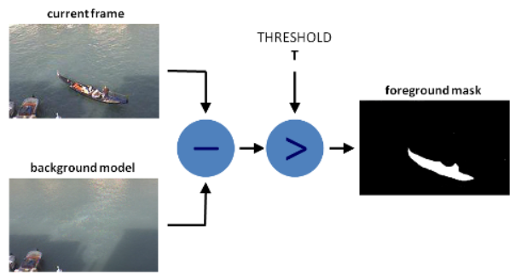

Fig. 1. Background Subtraction Example [5]

Once the background subtraction has been done, the resulting masked image will display a white pixel with the value of 255 for pixels that the background subtraction algorithm is almost certain is a foreground element as seen in the example in Fig. 1. The masked image will also contain Gray pixels with a value of around 127 for pixels that are likely to be foreground elements. These pixels could represent objects such as shadows or foreground elements that have not change in value as much as some of the other foreground element pixels. Some examples of Gray pixels could be the feet of a basketball player since they will slightly be moving from frame to frame but may not significantly change in value between frames. Finally, the masked image will contain black pixels with a value of zero that represent background images since these pixels will not significantly change in value.

Once the masked image is computed, thresholding will be done to set the gray pixels to zero. This is done because we do not want to detect shadows as foreground elements. Since Basketball Dribble Coach can be used in various settings, this could result in many different shadows or weaker foreground and background detection. Setting these weaker foreground elements to zero values will allow the computer vision algorithm to pick out areas of the image that are highly likely to contain foreground elements such as the player or basketball. Once the thresholding is complete, morphological dilation will be done on the masked image to expand the regions of foreground elements. Dilation will be done to ensure that foreground elements are properly connected and count as a single contour. It may be possible for a single foreground element to be disconnected by a single or multiple pixels, resulting in a single object being classified as two different objects. Dilation will help by ensuring that connected components stay connected. This resulting masked image will then be run through the contours algorithm to determine where likely location of the player is. A contour is defined as an area within an image where there is a significant change between a pixel and its neighboring pixels. Usually, contours are present around the outlines of objects. In the case of the background subtraction masked image, the contours will represent the boundaries between the background dark pixels and the foreground light pixels. Since the player will be a part of the foreground element, computing the contours of the masked image will result in the outline of the player. Once the player’s contour is computed, a bounding box around the player will be drawn on the real-time frame. Also, this player location will be stored within the program to compute things such as where the target dribbling locations should be located, where the basketball is highly likely to be located and to ensure that the player is properly in the frame.

After the background subtraction and player detection have been completed, the basketball detection will then execute. For basketball detection, color filter tracking will be used. I chose to use color tracking as the basketball tracking algorithm since color tracking is efficient and effective for tracking certain colored objects. Since Basketball Dribble Coach is a real-time application, more rigorous tracking techniques will likely not be supported on users’ laptops or personal computers. Therefore, I thought it was an appropriate tradeoff for slightly less accurate tracking performance with a slightly higher rate of false positives with color tracking then a more accurate tracking performance with a lower rate of false positives that would result in a lower FPS and worse user experience for the basketball player using the application. To help improve the color tracking performance, the color tracking will only search the foreground elements for the basketball’s location. Since the basketball is going to be moving rapidly from frame to frame, it is almost guaranteed to be fully classified as a foreground element in every frame. Therefore, searching only the foreground elements for the basketball will reduce the computation time and reduce the number of false positives produced by the application. Since Basketball Dribble Coach can be used in many different environments, these different environments may contain different levels of lighting, resulting in a different color for the basketball in every frame. To help detect the basketball’s color within each frame in the most light invariant way, I chose to use HSV color filtering. HSV color filtering stands for Hue Saturation Value where the Hue is the base color being detected. For the case of a basketball, the base color is orange. The saturation controls the depth of the pigment. More saturation means a darker tint to the color while a lighter saturation means a lighter tint to the color. The value of the color represents the amount of lightness or darkness contained within the color. This is especially useful for color tracking in that the amount of light contained within a certain color will be changing from frame to frame. I will determine an optimal HSV value for color tracking by creating an HSV track bar application that will allow fine-tuning of each of the three HSV color parameters.

The resulting color filter will contain a masked image where white pixels with a value of 255 represents areas within the image that match the color filter and dark pixels with a value of 0 represent areas within the image that do not contain the color filter. I will then execute the contours algorithm that will return a list of contours that could contain the basketball. To help reduce false positives, I will first check the properties of each contour. For example, I will check the area, height, and width of each of the contours to determine the likelihood that a particular contour is a basketball. For example, a basketball contains roughly the same height and width. This domain knowledge can be used to help remove false-positive contours that do not contain similar height and width values. Once the most probable contour representing the basketball is found, a bounding box will be drawn around the basketball and the basketball's location and bounding box properties will be stored within the application for intersection detection with the targets. Next, the targets will be drawn on the screen using the detected player and basketball properties. The targets will be located approximately at the waist of the player and will be sized to approximately the size of the detected basketball. The waist location for the targets was determined because many coaches and players know that keeping a lower dribble allows for faster and more accurate dribbling. Many coaches strive to have their players keep their dribbles around their waist level to enable these skills. The targets will be roughly the size of the basketball to enable more accurate dribbling by the player. Because the targets will be roughly the size of the basketball, the player will have to be more accurate with their dribbling to ensure that the ball fully intersects with the target locations.

Next, the intersection detection will be executed between the detected basketball location and the target dribbling locations. The intersection will be computed by determining whether the bounding rectangles around the target dribbling locations and the detected basketball position intersect. An intersection will be classified as a successful dribble repetition. To ensure that a single dribble repetition is not counted multiple times, a Boolean flag will be stored to represent which target needs to be dribbled to next. This means that until the basketball is detected to intersect the other target, a single basketball target intersection will not be counted multiple times. Put another way, the basketball target intersection must alternate between the left and right sides to count as a valid repetition. The number of repetitions completed by the player will be displayed on the screen in real-time.

For face detection, the Haar Cascade algorithm will be used. The Haar Cascade algorithm trains a classifier to pull out the most relevant facial features from an image to determine the location of a face within an image. This training is done by first selecting several features that will be detected in various images. Some of the training images contain pictures that contain one or more faces while other training images contain pictures that contain no faces. The classifier will then train to determine which features most represent a face. A few examples of potential features could be horizontal and vertical lines, edges, various rectangle points, among others. Once the features are detected within the image, the features will be searched for in different sizes of images. This is done to support facial recognition of various sizes. A face will not always show up as the same size between different images as the size of the face depends on the distance to the camera, the amount of zoom on the camera, and the individual. Once the Haar Cascade classifier is trained, the trained model can be used to detect the location of faces within images that were not contained in the training data set. This is what I will be used to detect face locations within Basketball Dribble Coach. I chose to implement the Haar Cascade classifier for facial detection because it combined the simplicity of use with the efficiency of computation. Since Basketball Dribble Coach is a real-time application, the face classifier needs to be efficient in classifying the location of faces within the image. During my research, I determined that Haar classifiers are one of the most efficient face classifiers. Deep learning-based classifiers usually require more computational power to execute, resulting in a lower FPS during detection. I did not want to significantly reduce the FPS experienced in my application just for more accurate face detection. The idea is if the player’s face is found within the image, the program will conclude they are looking up. This is because, in many images, a person is looking directly at the camera, meaning that if the player was looking at the camera, it is highly likely that their face will be detected correctly. However, if they are looking down at the basketball while dribbling, the Haar Cascade classifier will be less likely to classify their face as a face, which means we can count the occurrences of when a face is not detected within the image and keep track of those as the number of times the player has looked down at the basketball while dribbling. This number will be displayed on the camera frame in real-time. Finally, a stopwatch will be displayed on the screen to allow the player to keep track of the amount of time that they have practiced and determine how long it took them to complete a certain drill so they can improve that over time. These are the major computer vision and other algorithms used in be Basketball Dribble Coach application.

**User Interface Mocks**

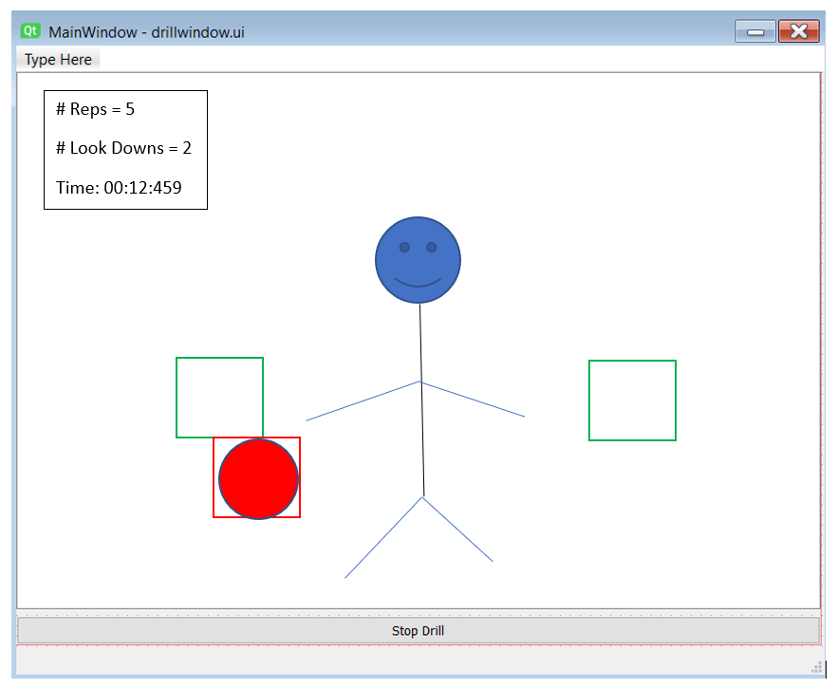

Fig. 2. User Interface Mock

Fig. 2 shown above is a mock of the basic user interface for Basketball Dribble Coach. To allow focus on the computer vision aspects of the project, this will be a single-window application. The white area above represents the area where the real-time camera feed will be shown. As can be seen, the basketball will be detected, and a bounding box will be drawn around it. The green squares represent the target dribble locations. The upper left corner will show the running totals for the number of completed reps, the number of times the player has looked down during the drill, and the current elapsed time during the drill. These values and bounding box locations will change during drill execution. There is a single button at the bottom of the window that toggles starting and stopping the dribbling drill. All the data will be stored in the OpenCV real-time camera feed and processor and displayed in the application window above when active.

**Dataflow**

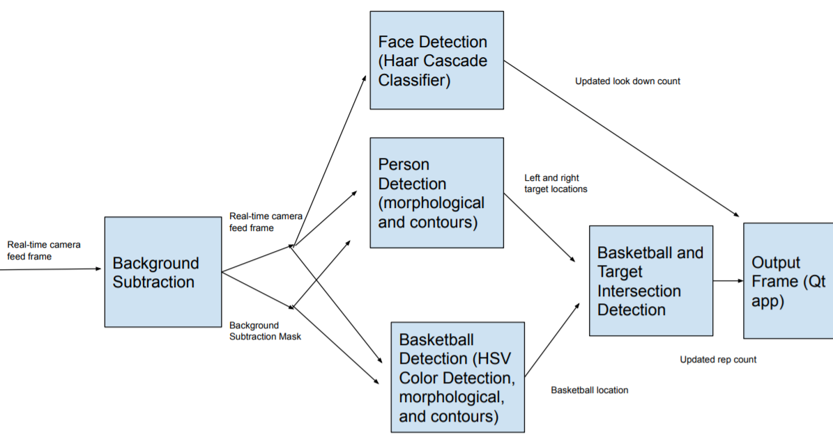

Fig. 3. Basketball Dribble Coach Dataflow

Fig. 3 above shows an overview of the dataflow between the components of the project. Each of these components was explained in detail in the previous sections. The number of completed repetitions and the number of times the player has looked down while dribbling will be stored within the application. This information will be directly shown on each frame, giving the user indication of their results. The time elapsed during the drill will also be computed for every frame and displayed on the screen. I contemplated adding additional data such as allowing the user to specify the number of repetitions they complete, the amount of time they run the drill, or the type of drill; however, I determined these did not add significant value to the computer vision focus of this project and class. Instead of adding additional user experience features that could be added in the future, I decided to focus on the computer vision aspects of the project instead. Therefore, the specific data that is stored within Basketball Dribble Coach is related to the core of the application and the computer vision algorithms.

Also to data that is directly displayed to the user, additional data will be stored to facilitate intersection detection and properly updating the user’s displayed information. For instance, the basketball location, player location, and target locations will be stored within the application to help facilitate intersection detection. Additionally, various flags and values will be stored to properly update the number of dribbles, the number of look downs, and the time elapsed. A Boolean flag will be stored that represents the target that will be intersected next to count as a repetition. This Boolean flag will prevent a single intersection from being counted multiple times between subsequent frames. The last frame the player looked down will also be stored to prevent a single look down from being counted multiple times between subsequent frames. I also anticipate other variables and flags may be required to support the required functionality for this application.

1. **Evaluation**

**Test and Improvement Plan**

To test the application, at least three different locations containing at least two different lighting conditions will be tested. For each of these environments, a video will be created containing 60 seconds of detection. Each of these videos will be analyzed to determine the accuracy of repetition counting and look down detection. If any modifications need to be made for player detection, the background subtraction algorithm will likely be modified. Since the player detection is utilizing the results of the background subtraction algorithm, changing parameters about the background subtraction algorithm will have a direct impact on the player detection results. If any changes need to be made for facial detection, the Haar Cascade classifier algorithm will be modified. Various parameters control the Haar Cascade classifier results. I anticipate the speed of classification to be the most likely factor that will need to be tuned in the cascade classifiers. If changes to the basketball detection need to be made, the HSV color detection or basketball detection method may need to be modified. The results from these tests will help determine what areas will need to be improved in future iterations.

**Success Definition**

Success for this project will be defined by at least 90% accuracy of repetition and face detection counting. The test will not analyze each video frame by frame, but each video will be analyzed to determine when misclassifications were made and how often they occur. Once the analysis is completed, patterns will be drawn for similar misclassifications. Misclassifications could occur during certain environments with more difficult detections such as similar colored objects or more objects in the background of an image. Therefore, a 90% success rate will be considered a successful implementation of this project.

**Test Conditions**

For the selection of the different environments, one environment will contain a blank backdrop with a solid color. This environment will represent the easiest and simplest environment that a player could use the Basketball Dribble Coach application. A second environment will contain various items in the background where some are moving and are of similar color to the basketball. This environment will test the background subtraction’s effectiveness. The final environment will be against a window with a different colored light. This environment will test the basketball color detection and how the project handles reflections against a window. These three environments will test various edge conditions of the Basketball Dribble Coach’s detection capabilities. Success in these three different environments will show Basketball Dribble Coach’s effectiveness in many types of environments and backgrounds.

**Test Subjects**

Since I am the only member on this project, I am not able to test this on any other people. However, I will be able to test this with different clothing. The difference in clothing will be used to simulate different people using the Basketball Dribble Coach application. This different clothing will also help determine the usefulness of the person in basketball detectors when different clothing is worn by the player. Some of these pieces of clothing will be of similar color to the basketball to test the program’s effectiveness with color detection. Successful detection with these different clothing combinations will prove Basketball Dribble Coach’s detection effectiveness with different foreground elements.

**References**

[1] https://sportsshow.net/top-10-most-popular-sports-in-the-world/

[2] https://dribbleup.com/

[3] https://opencv.org/

[4] https://www.Qt.io/

[5] https://docs.opencv.org/3.4/d1/dc5/tutorial_background_subtraction.html